ORD

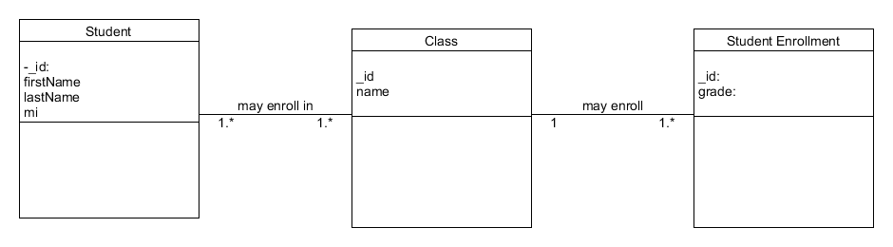

NoSQL Data Structure

